**(1) Import seaborn library onto the dataset :**

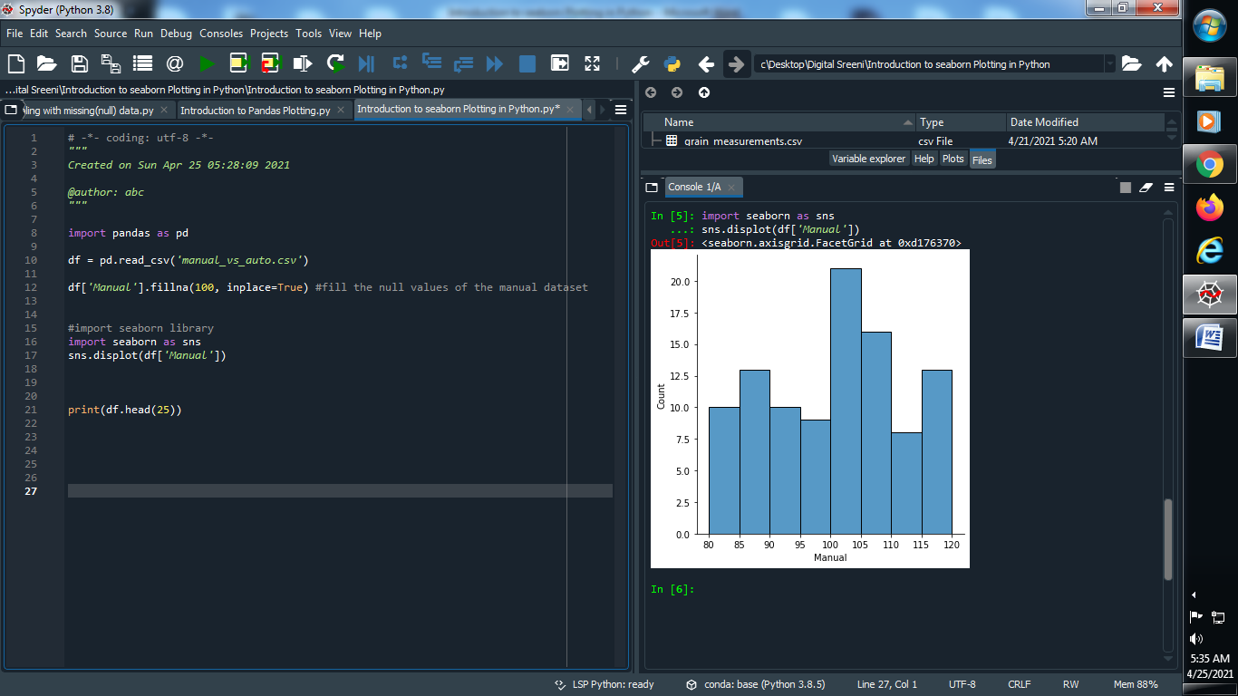

**Output :**



**(2) Import kdeplot onto the dataset :**

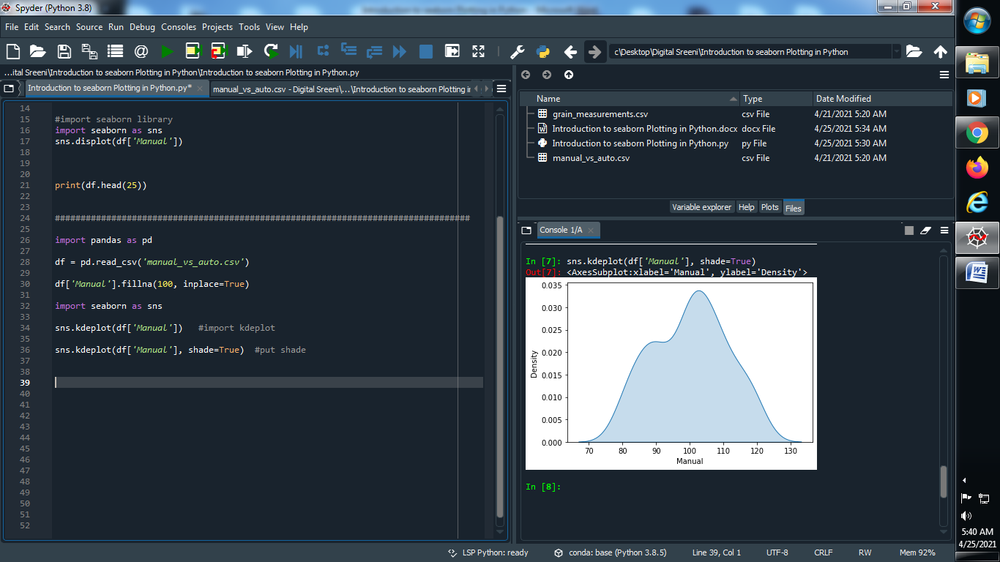

**Output :**



**(3) Apply this kdeplot onto all the dataset :**

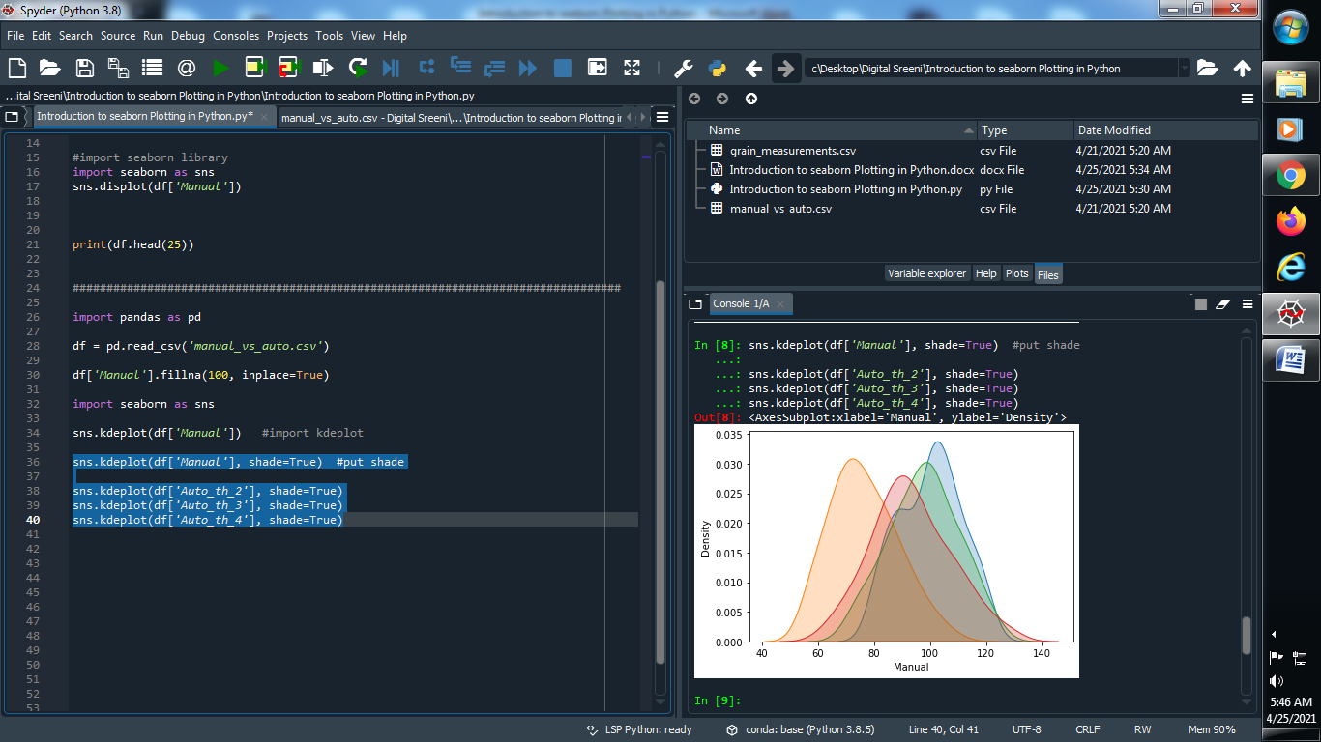

**Output :**



**(4) Apply scatter on dataset :**

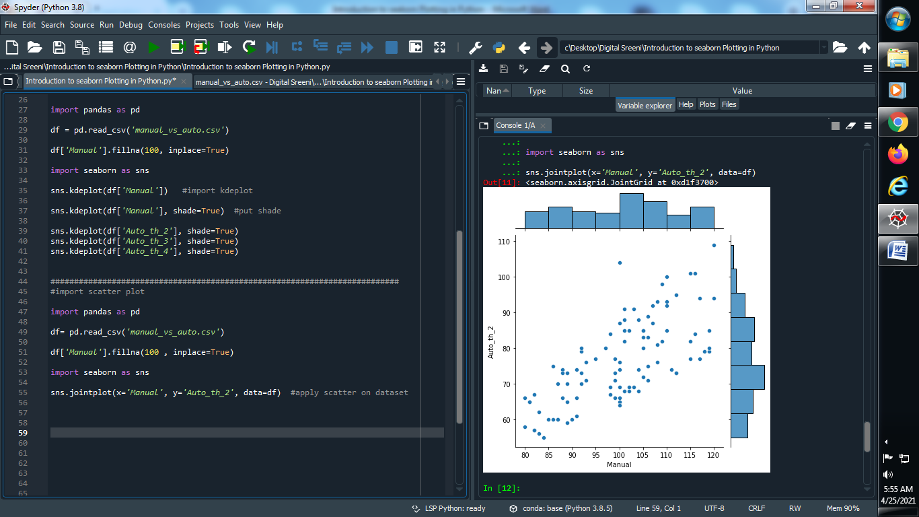

**Output :**



**(5) Use kde on above dataset :**

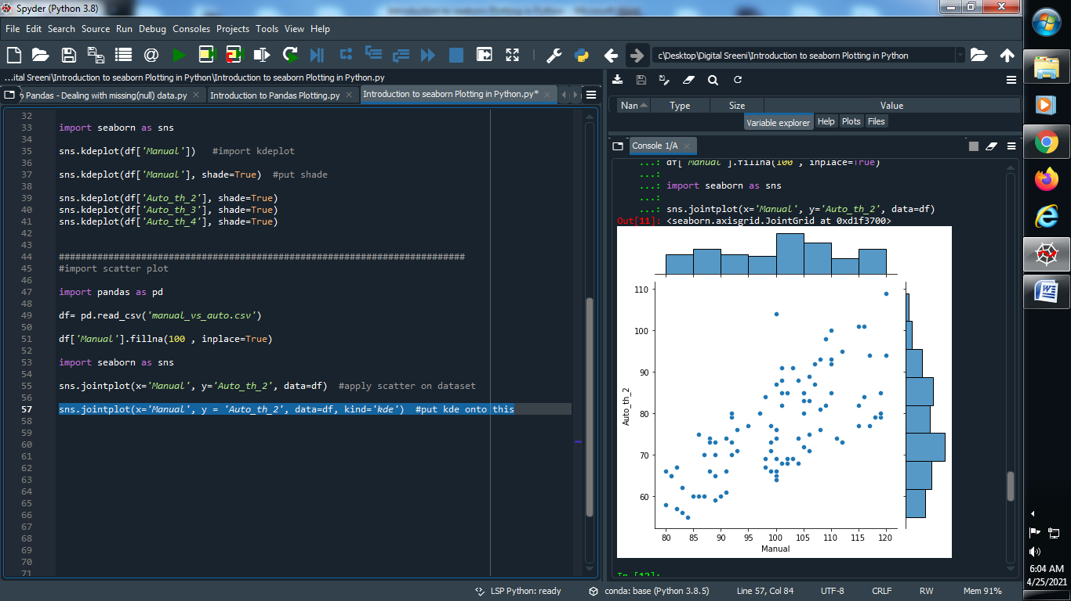

**Output :**

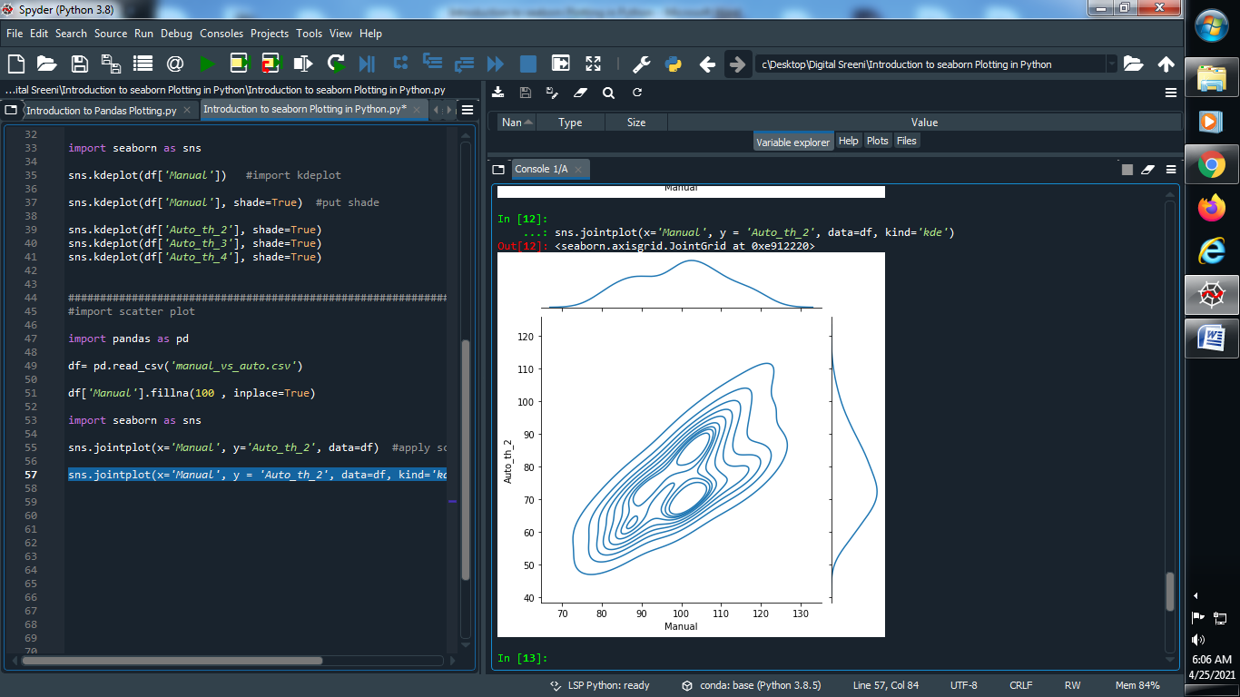

**(6) Compare the plots :**

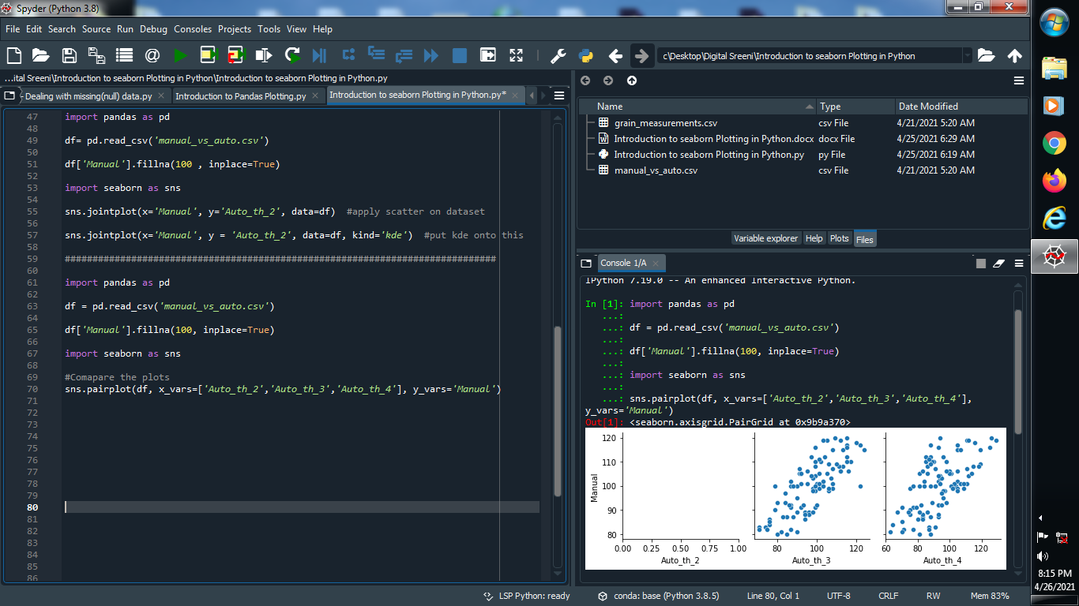

**Output :**



**(7) Compare two columns dataset using lmplot :**

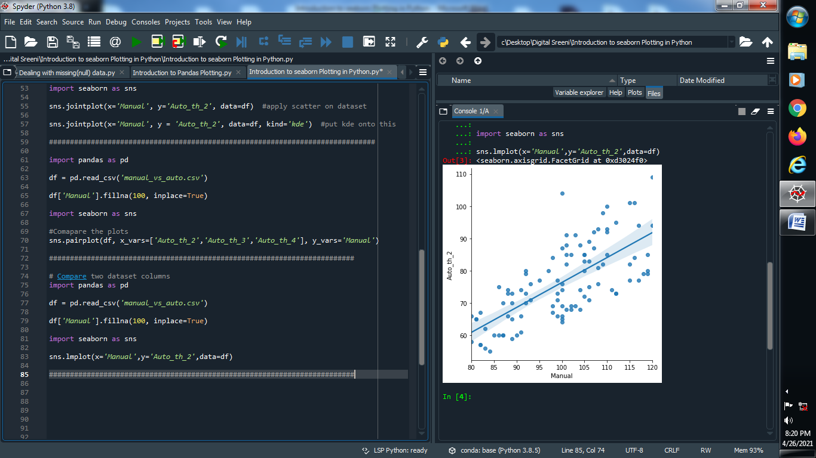

**Output :**



**(8) Use hue :**

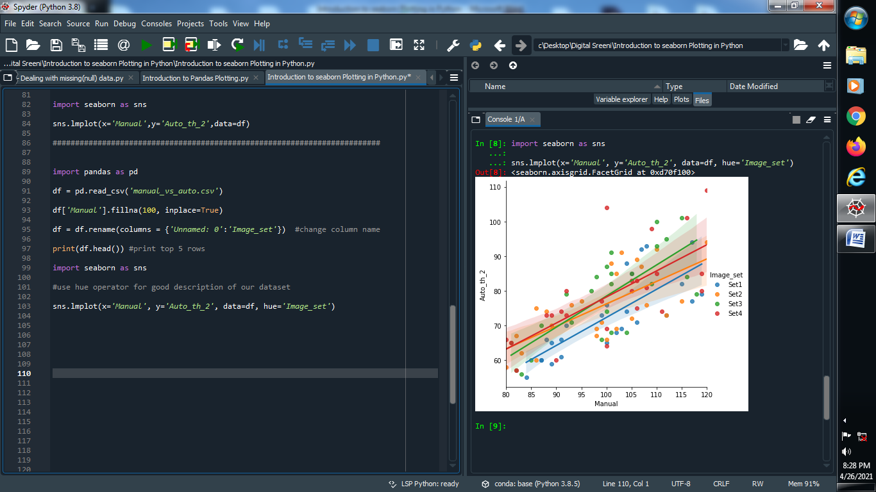

**Output :**



**(9) Display Equation :**

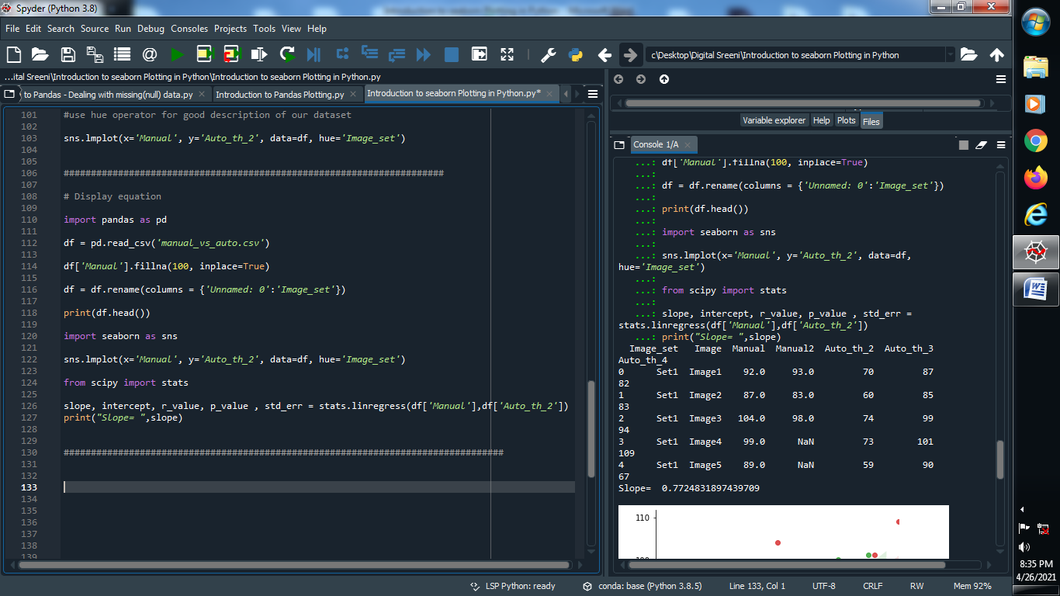

**Output :**

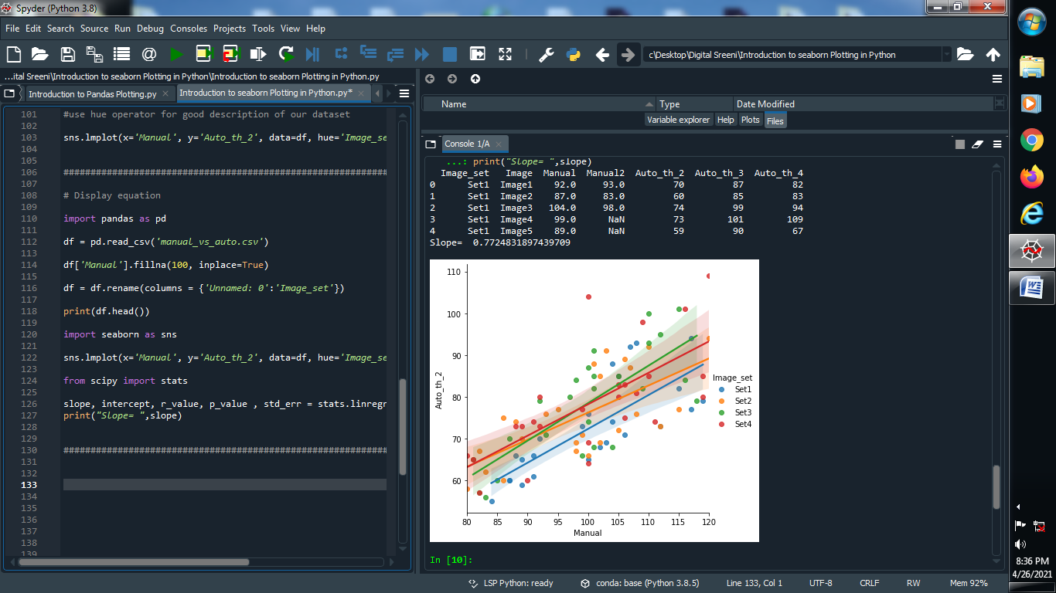

**(10) Swarm plot using pandas :**

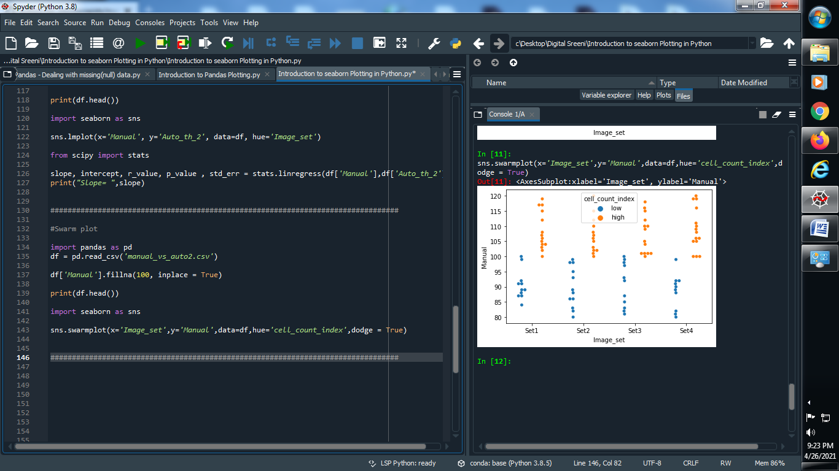

**Output :**



**(11) Correlation between different columns :**

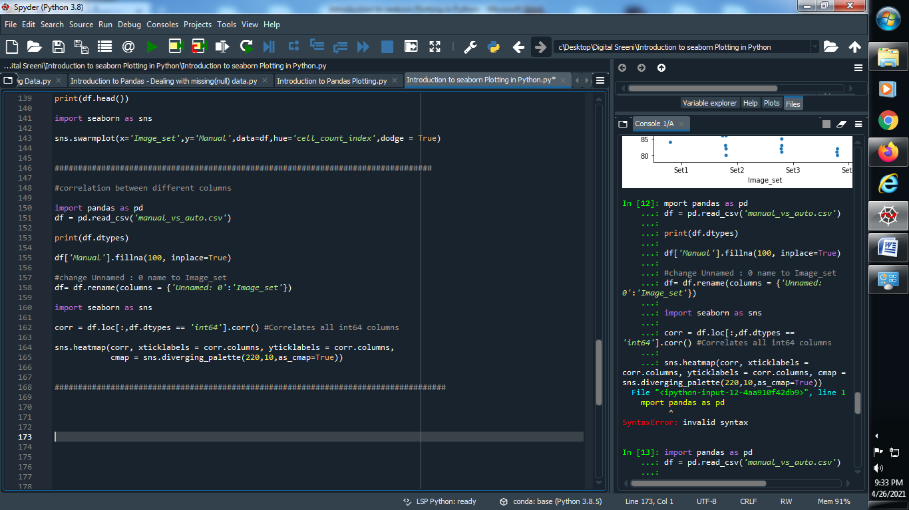

**Output :**

